**Photoelectric Effect**

**Physical Chemistry II Lab**

**CHM4411L**

**Dr. Clark**

**1. Objective and Relation to Lecture**

Provide a brief description of the purpose of the experiment. What are you trying to achieve or learn?

The photoelectric effect holds a special place in the interface between quantum mechanics and chemistry. Primarily, it reflects a property of light and not matter, which is that the energy of a photon is proportional to its frequency with a proportionality constant of Planck’s constant. The appearance of Planck’s constant in both Planck’s blackbody radiation law and as a proportionality constant for the photoelectric effect suggests the quantization of energy levels in matter, which is one of the main subjects of CHM 4411.

**2. Introduction / Theory**

Our knowledge about the atomic structure of matter is largely based on experimental data gathered from experiments of absorption and emission of radiant energy by atoms. Obviously, understanding the nature of radiant energy is necessary in order to interpret the results of such experiments. Electromagnetic radiation consists of oscillating electric and magnetic fields, which are perpendicular to each other and travel as a wave through the vacuum. The wave has a constant speed c, called the speed of light. If the wave moves through a medium other than the vacuum, the speed of light is reduced by a factor of n, where n is the refractive index of the particular medium.

The two main characteristics of a wave of electromagnetic radiation are its wavelength  and frequency , which are directly related to the speed of light.

*c *  : distance between adjacent maxima of the wave (nm) (1)  : number of oscillations per second (s-1; 1 Hz = 1 s-1)

c : 2.9979 X l08 m/s

The reciprocal of the wavelength ~ (cm 1 ) , called the wavenumber, is frequently used in spectroscopy.

Up until the late 1800's, the wave picture of light was the prevalent theory as it could explain most of the experiments done on light. One exception was that associated with blackbody radiation, the characteristic radiation that a body emits when heated. It was known that this radiation changes in nature as the temperature changes. Experiments using perfect emitters and absorbers (blackbodies) show typical curves of the intensity of radiation (per unit time and unit area) vs. the wavelength at constant temperature. They reveal a maximum at a characteristic wavelength, which shifts to shorter wavelengths as the temperature is increased. This behavior is reflected in the observation that a red-hot object is cooler than a white-hot object.

When the wave picture of light was applied to the blackbody radiation, it failed. It predicted that the radiation intensity, I, at a given temperature should vary with wavelength as

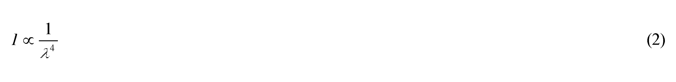

which agrees with the experimental data for long wavelengths, but diverges for short wavelengths.

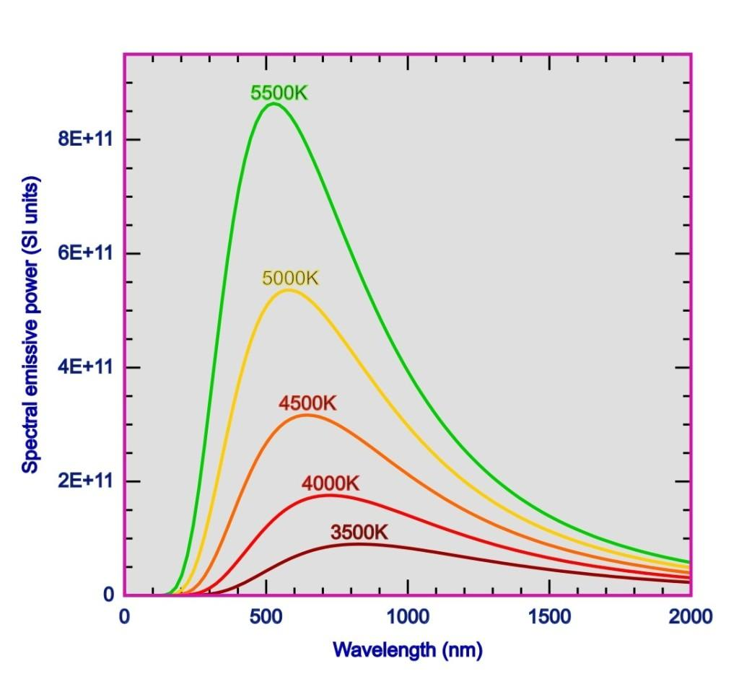

**Figure 1:** The energy distribution in a black body cavity at several temperatures.

In 1900 Max Planck devised a theory of blackbody radiation which gave good agreement for all wavelengths. In this theory the molecules cannot vibrate with arbitrary energies but instead the vibrational energies can only have discrete values. The magnitude of these energies is given by the formula

Furthermore, he postulated that when a molecule goes from a higher energy state to a lower one, it emits a quantum (packet) of radiation (now called a photon), which carries away the excess energy. The photons can be thought of as particles each having the energy *h * . The integer *n* simply counts the number of photons involved in the process. Planck was awarded the 1918 Nobel Prize in physics for his work on the quantum theory.

In 1905 Einstein explained the photoelectric effect based on Planck's quantum theory. In this phenomenon electrons are emitted from metal surfaces when they are exposed to UV light. In the experiment carried out in this lab, UV light emitted by a high pressure mercury lamp is shone on the metal cathode of a high vacuum photocell. Different wavelengths of the light can be selected by placing a filter between the light source and the photocell. Each photon of the chosen wavelength of light transfers enough energy to an individual electron in the cathode to eject it from the metal surface. These electrons, called photoelectrons, move towards the anode establishing a photoelectric current. A standard microammeter is used to measure this current and a voltmeter measures the potential difference, or voltage, across the cathode and the anode.

When a photon of energy *h * hits the metal cathode it gives up some or all of its energy to an electron in the metal surface. A certain amount of energy is required to eject the electron from its bonds in the metal. This energy is called the work function of the metal, . Usually  is measured in energy units of electron volts (eV), where 1 eV is the energy a particle with the charge of an electron (e = 1.60219 X 10-19 C) gains when it is accelerated by a potential difference of 1 Volt (1 eV = 1.60219 X 10-19 J since 1 V X 1 C = 1 J). The remaining energy appears as kinetic energy of the ejected electron. Thus, the maximum kinetic energy the electron can have is given by



If the value of the work function  of the metal is greater than the energy of the photons that hit the metal, electrons cannot be released and consequently the photoelectric effect does not occur.

In this experiment you will apply an increasing voltage, or potential difference, across the photocell and measure the corresponding photocurrent. Note that as you increase the voltage the current produced in the photocell decreases. The current decreases because the voltage is applied as a reversing potential. The voltage at which the photoelectron flow stops (where you measure 0 µA) is called the stopping potential *Vo.* For the electron to be ejected, its maximum kinetic energy must be equal to the potential energy *eVo* of the photocell's electric field.



Combining equation (4) and (5) leads to

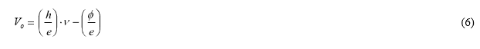

According to equation (6) a plot of the stopping potential vs. the applied frequency of light yields a straight line. Planck's constant can be calculated from the slope and the work function from the intercept of the curve. Note that the photoelectric effect does not occur for light below a specific frequency, called the cut-off frequency, , where *Vo * 0 (x-intercept).

**3. Materials and Equipment**

1. voltmeter
2. ammeter
3. mercury lamp housing and power supply
4. housing containing the photocell

**4. Safety Precautions**

* The lamp housing gets very hot, do not touch this after it is turned on to avoid burns.
* Lab coat, glasses, and closed toed shoes are required for this lab. Gloves may be used at your discretion, but note a burn is worse when wearing latex gloves.

**5. Experimental Procedure**

The complete setup essentially consists of several components: l.) voltmeter, 2.) ammeter, 3.) mercury lamp housing & power supply and 4.) a housing containing the photocell. First the voltmeter and ammeter have to be connected to the photocell apparatus. If this is not done already, connect the positive (red) and negative (black) of the voltmeter leads to the positive and negative terminals of the photocell apparatus. Similarly, connect both of the micro-ammeter leads to the terminals of the photocell apparatus. On the right side of the unit a wheel with five different filters covers the entrance to the photocell. The mercury lamp has to be placed in a line in front of the filter wheel and its distance to the photocell should not be altered during the measurements.

First thing that you will want to do is to carefully check (the lamp housing gets very hot) that the Hg lamp and the photodiode housing are firmly attached to the 60 cm metal track by their locking screws. Turn on the power strip for the apparatus. Power up the Hg power supply using the orange button on the back of the Hg power supply. Power up the BroLight DC Current Amplifier (DC/CA). Power up the BroLight Tunable DC (Constant Voltage) Power Supply I. Check that the distance between the Hg light source and the vacuum photodiode are roughly 35 cm apart. See that the 365 nm filter is the active light filter on the filter wheel and that the aperture is at 4. The Hg lamp needs about a 10-minute warm-up. Wait approximately 10 minutes before proceeding

You will need to zero the DC/CA (see the DC Current Amplifier figure below). Remove the red & black RCA cords from the photodiode on the back of the photodiode housing. Push the yellow SIGNAL button in to calibrate it. Adjust the Current Ranges Calibration knob to zero amps while using a setting of 10-13 amps with the Current Ranges knob.

After completing the current zeroing, return the SIGNAL button to measure and reconnect the RCA cords to their proper connections on the back of the photodiode housing. You will now wish to carefully remove the cap from the Hg lamp. It is very hot and can burn you. Remove the cap from the photodiode housing. See that the five filters are labeled according to their wavelength as follows: 365 nm, 405nm, 436 nm, 546 nm and 577 nm. The filters are found on the filter wheel of the photodiode housing. Set the filter wheel to the 365 nm filter first.

In the Tunable DC (Constant Voltage) Power Supply figure above, you will set the Voltage Range Switch (DC) to the -4.5V-0V setting (out). Start taking measurements. Set the Voltage Adjust knob - it is the knob on the right side or DC side and not the Filament side - so that the bias shows 0 V. Record the photocell current at 0 V as your initial data point. Increase the voltage supplied to the photocell using roughly equal voltage increments or intervals. Please note that the amp should not exceed 1999. It will display “1___“ for values over 1999.

**6. Data Collection**

Record the voltage and current (0.1 µA resolution) at each step. As your final data point, record the voltage when the current reads zero. You may need to adjust the voltage by smaller intervals to reach zero current. Now, reverse the DC voltage on the Voltage Adjust knob decreasing the current in similar increments or intervals. Repeat this procedure for each filter. Always be sure to zero the amplifier output before applying voltage. To zero, unplug the red and black cords from the photodiode housing, push the yellow SIGNAL button in to calibrate it, and adjust the Current Ranges Calibration knob to zero amps.

**7. Calculations and Analysis**

1. Plot the current (ordinate) vs. voltage (abscissa) data for each of the filters on the same plot. Fit a curve to each of the five data sets and determine the stopping potential *Vo* (and the error in *Vo*).
2. Discuss what happens if you increase the intensity of the light using light of a wavelength a) above the cutoff wavelength and b) below the cutoff wavelength.
3. Prepare a table showing the applied wavelength (nm) and frequency (Hz) of the light, and the stopping potential *Vo* .
4. Graph the stopping potential as a function of the frequency of the light. According to equation (6) you should be able to fit your data and determine Planck's constant. Further, calculate the work function , and the cutoff frequency and wavelength.
5. Explain in your own words why the particle characteristics of light are essential to understanding the photoelectric effect.
6. Can you make some suggestions as to the nature of the cathode metal based on your value for the work function (Explain)?
7. Calculate the energy of the photons for each wavelength of light used in the experiment. Use the formula

Present these energies in a table alongside their corresponding frequencies and wavelengths. Discuss how photon energy relates to the stopping potential for each light source.

1. Calculate the quantum efficiency of the photoelectric effect for each wavelength. The quantum efficiency is defined as the ratio of the number of photoelectrons emitted to the number of incident photons. If provided with the intensity and area of the light beam, use the following formula to estimate the number of photons:

Where P is the power of the light source, t is the exposure time, and A is the area. Compare the efficiencies across different wavelengths.

1. Discuss the potential effect of temperature on the work function of the metal used in the experiment. If the metal is heated, how would this affect the energy required to emit electrons? Would the stopping potential change as the temperature increases? Explain your reasoning based on the relationship between thermal energy and electron emission.
2. Compare your experimentally determined cutoffwavelength (the longest wavelength at which electrons are emitted) with the theoretical cutoff wavelength calculated from the work function using:

Discuss any discrepancies between the experimental and theoretical values and possible sources of error